SOUTH PASADENA MIDDLE SCHOOL
DAILY BULLETIN
Oct. 2, 2018

WORDS OF WISDOM – GOALS

Word of the Day - protrude (verb): to swell or extend outward; bulge, pop out. Example: His eyes protruded from their sockets.

Tuesday, Sept. 2, 2018 – “ODD” SCHEDULE -
Period 1 8:00 - 9:45
Brunch 9:45 - 10:00
Period 3 10:05 - 11:45
Lunch 11:50 - 12:20
Homeroom 12:25 - 12:55
Period 5 1:00 - 2:40

Fun Fact: Neil A, (aka Neil Armstrong) if spelled backwards, spells Alien

Step It Up: We thank everyone who donated to the Step It Up Fundraiser and the party will be held on Tuesday October 16th

LIBRARY:
Free people read freely, and all libraries celebrate the right to access books. Come to the library and check out our display of books that have been banned by different organizations throughout the years. If you've read one, put your opinion of the book up on our display and get your picture taken.
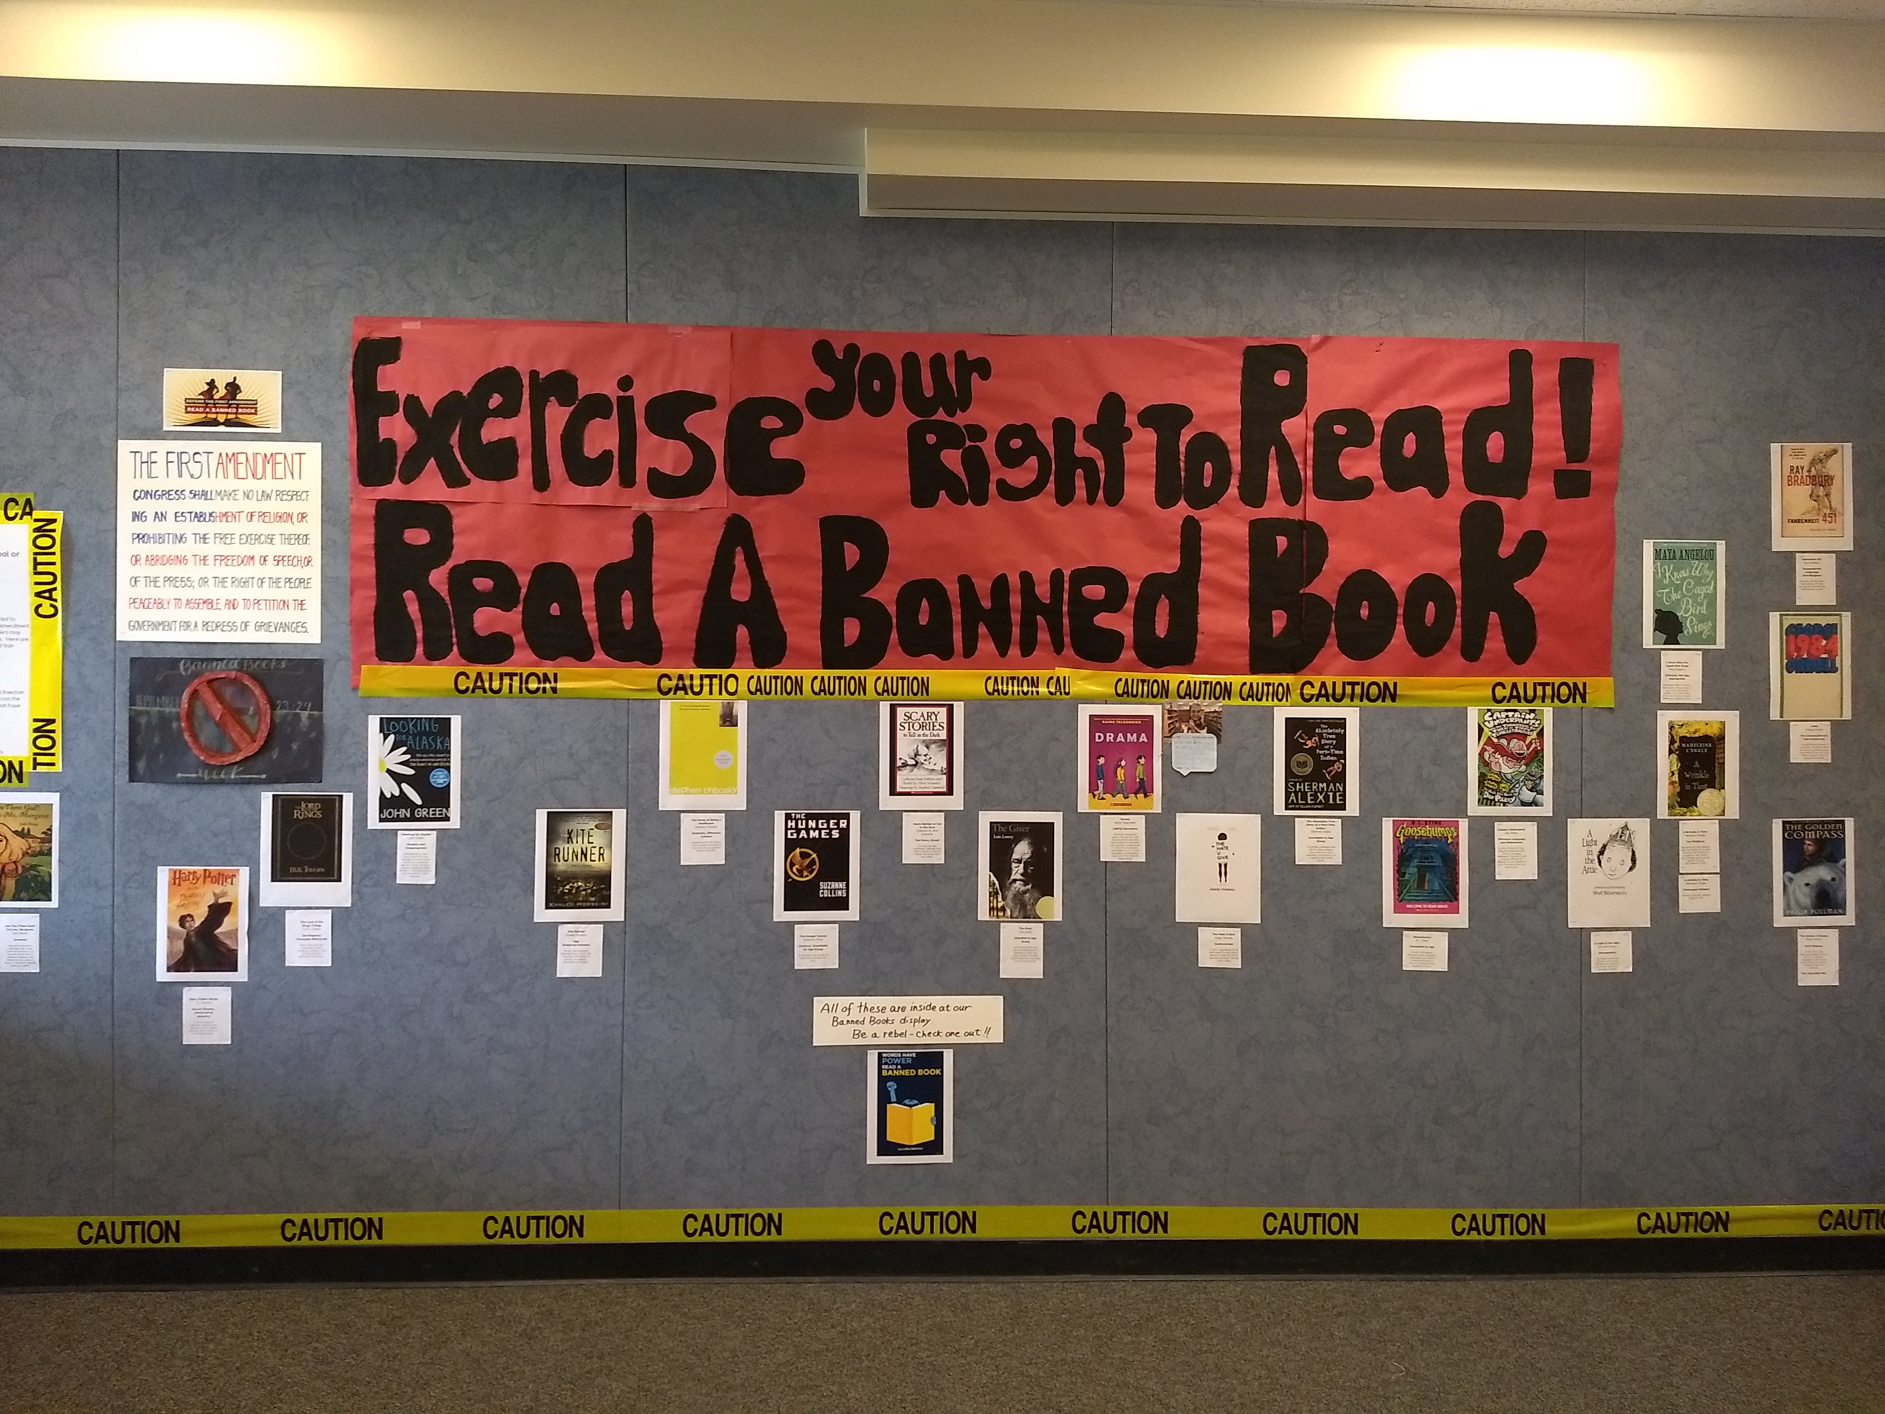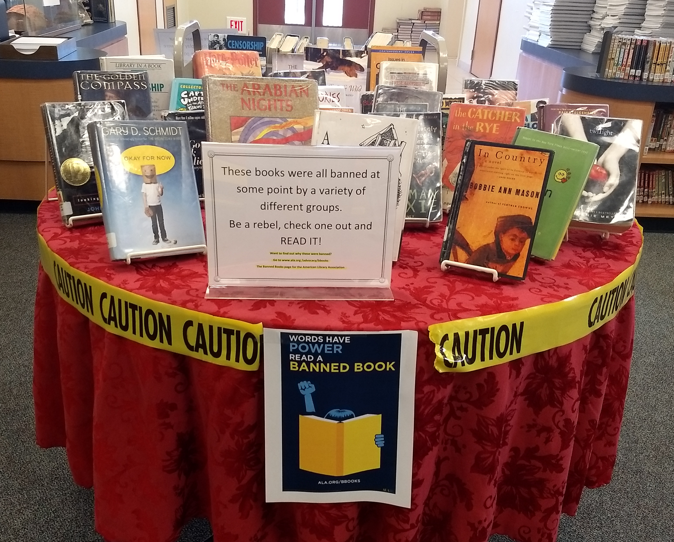

The library has a ton of brand new books ready for you to check out! Series like the Mother Daughter Book Club, Seven Wonders and Mr. Limoncello's Library, as well as an entire series on singers like Pitbull, Beyonce and Nicki Minaj. Come up and see what we have!

An announcement from Captain Obvious: Let's remember that there is no running or games of hide and seek allowed in the library. Offenders will be asked to leave the library immediately.

CCF, which stands for Campus Christian Fellowship, will finally begin this Thursday during lunch in room 217. CCF this year will be every 1st and 3rd Thursday of the month. This student led club is open to everyone, so please feel free to join us and don't forget to bring your lunch.

Do you enjoy art, music and dance or have an interest in writing, producing films and taking photos? Then join us and have fun unleashing your inner artist with PTA Reflections! This year’s theme, “Heroes Around Me,” calls for your own unique interpretation through the arts. Pick up submission guidelines and an entry form today from Mrs. Tanaka in Room 102 or the main office, and return by October 24th. For inspiration, visit the Reflections virtual art gallery and learn more about prizes and scholarships at PTA.org/Reflections.

Calendar/Events
Tuesday:
- "Odd" Schedule
- Project Wisdom: Goals

Wednesday:
- "Even" Schedule
- Project Wisdom: Successful Living
- School Site Council Meeting at 3:00 PM
- 8th Grade Flag Football (Home) at 3:30 PM

Thursday:
- "Odd" Schedule
- Project Wisdom: Attitude

Friday:
- "Even" Schedule
- Project Wisdom: Commitment

